**Mock Paper – 2**

GUIDELINES

**Time: 2 hours** **Total Marks: 100**

**General Instructions:**

1. *Answers to this Paper must be written on the paper provided separately.*

*2. You will not be allowed to write during the first 10 minutes. This time is to be spent in reading the question paper.*

*3. The time given at the head of this Paper is the time allowed for writing the answers.*

*4. Attempt all five questions.*

(By Subrata Sir & group of ICSE and CBSE school teachers)

**QUESTION 1**

*(Do not spend more than 30 minutes on this question.)*

**[ 20 ]**

**Write a composition (300-350 words) on any one of the following:**

1. You have been given a chance to spend a day in the past. Which age in the history of mankind would you choose and why? Describe how you spent this day.
2. A day in the life of a traffic police constable.
3. Religion has no importance in our lives today. Argue *for* or *against* the statement.
4. Write an original short story in which the central character is a nursery rhyme character,
5. Study the picture given below. Write a story or an account of what the picture suggests to you. Your composition may be about the subject of the picture or may take suggestions from it; but there must be a clear connection between the picture and the composition:

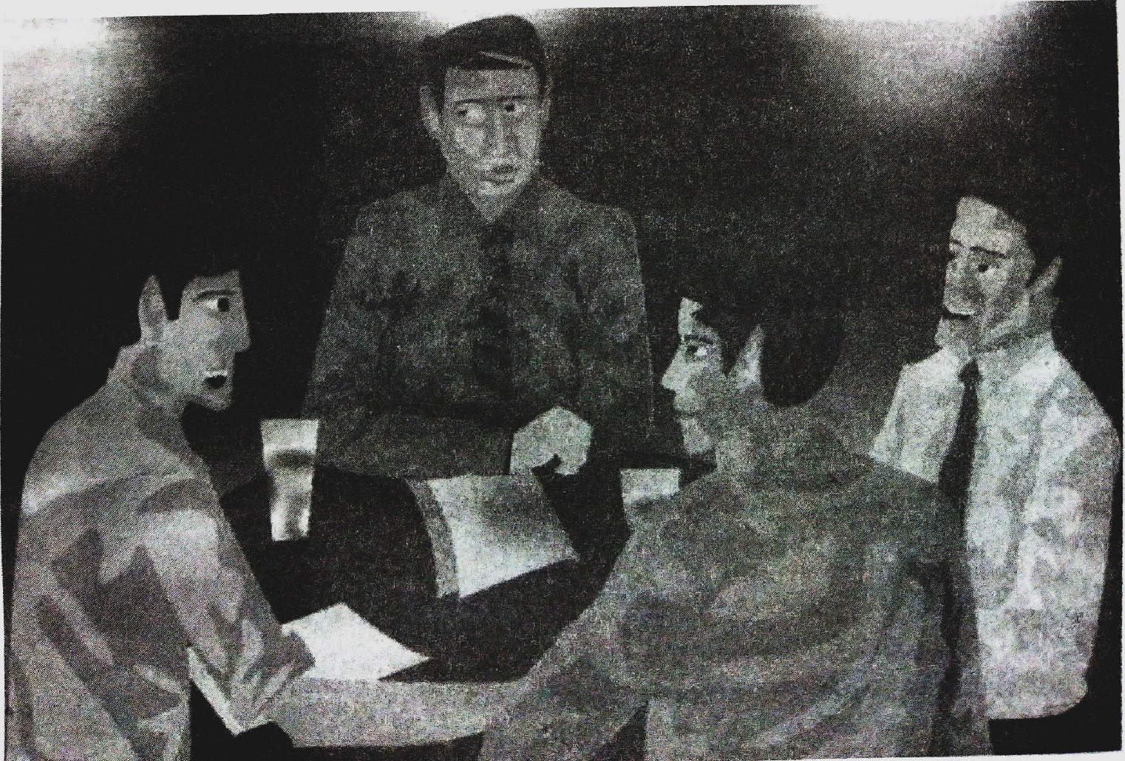

**QUESTION 2**

*(Do not spend more than 30 minutes on this question.)*

**[ 10 ]**

**Select one of the following:**

* 1. Your friend has fractured his leg and has been confined to bed for a month. Write aletter to him sympathizing with his plight and giving him details about the happenings in school.
  2. You found a bag containing some important documents on the seat of a bus you were travelling in. The address of the owner was in the bag. Write a letter to the owner of the bag asking him how he would collect his bag and telling him how you had come across it.

**QUESTION 3**

1. You are the secretary of the Quiz Club. Write a notice for the school notice board, inviting students from classes 7 and 8 to take part in the Inter-House Quiz Competition.
2. write an e-mail to a well-known. Quiz Master, requesting him to conduct the quiz.

**[ 5 + 5 ]**

**QUESTION 4**

**[ 20 ]**

**Read the following passage carefully and answer the questions that follow:**

In Paris he went to see Monsieur Audiat. Monsieur Audiat was careful as well as humble. Chris Selby was his only customer for watches and Monsieur Audiat was glad to have a regular twice-a-year profit rather than business every week with a risk of being found out. Chris found Audiat and his brothers in the back of the shop.

‘A thousand of the last shipment of watches had not worked; most of the others were *poorly* made; and all of them had been so badly packed that many had broken’. Audiat stood there hating Chris. He would have liked to kill him but did not want to destroy the *source* of a nice little profit. He promised that the next shipment would be perfectly all right.

Selby wanted the watches to be ready for him to take that night. He told Audiat just how he wanted the watches to be packed in the car. It's surprising how many watches you can put into one car, especially if the floor is a false one and the gas tank holds only two gallons of gas! Audiat promised again that this time his brothers would examine all the watches themselves.

Just after four in the morning Selby was in his car singing to himself as he drove past the gates towards the customs at Dover.

All his bags were opened by the customs man. Then he walked to his car. Everything went well, just as it always had -- the practiced smile and the easy manner all helped.

Selby was about to get into the car and drive away when there was suddenly a mad noise of whistles and then everything stopped. When the whistles blew at eleven o'clock on Armistice Day, everybody stopped and there was silence for two minutes in memory of the war dead. Chris Selby and the customs officer stood by the car and bowed their heads. You could hear the water against the dock and that was all.

Or rather that was almost all -- something else was heard too. From the car, not loud enough for anyone else to hear, it's true, but loud enough for the customs man, came the sound of five thousand watches ticking. They had all been wound by the Audiat brothers who had wanted to *please* Selby by making sure that this time he had watches that worked as well as watches that looked nice.

(a) Give the meaning of the following words as used in the passage. One-word [3]

answers or short phrases will be accepted:

1. poorly *(line 6)*

a. badly b. weakly c. sadly d. miserly

1. please *(line* 27)

a. To make happy b. To do a favour

c. To make a request d. To make happy

1. source *(line 8)*

a. origin b. starting c. beginning d. initial

(b) Answer the following questions briefly in your own words:

1. Why did Monsieur Audiat continue to do business with Selby? [2]
2. What had happened to the last shipment of watches? [2]
3. In spite of hating Selby, why did Audiat remain standing quietly? [2]
4. How were the watches packed? [2]
5. Quote a line from the passage which suggests that Selby had done this earlier. [1]

(c) In not more than 50 words describe what happened after Selby reached Dover. [8]

**QUESTION 5**

(a) In the following passage, fill in each numbered blank with the correct form of the word given in brackets. (Do not copy the passage, but write the appropriate word or phrase in correct serial order in the blank space.) [4]

Fame and public acclamation (i) (be) hers, but she (ii)

(do) not rest on her laurels. At about the time of her sixtieth birthday, she

1. (start) another great work. All her life, she (iv)

(love) tending the sick. Now she (v) (make) an attempt to

(vi) (establish) nursing as a recognised and honourable profession for women. She founded the Protestant Sisters of Charity or Nursing Sisters, Twenty women (vii) (enrol) provided with special uniforms and (viii) (house) together in a comfortable home.

(b) Fill in the blanks with the appropriate words: [ 4 ]

1. Mohana took up Science her mother's wishes.
2. The children left the park sunset.

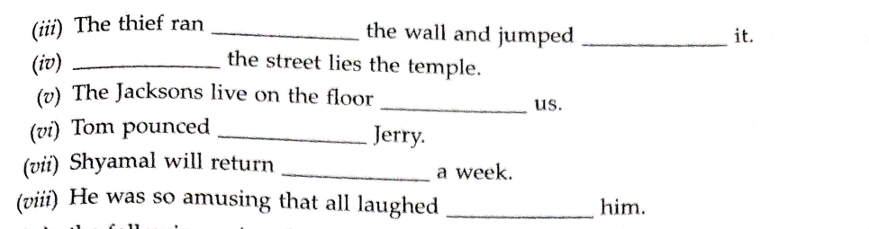

(c) join the following pairs of sentences without using *and, but* or *so:* [4]

(0 The bottle was on the table. It was filled with water,

1. The bottle, which is on the table, was filled with water.
2. The bottle, which was on the table, was filled with water.
3. The bottle, being on the table, was filled with water,
4. The bottle, which had been on the table, was filled with water.

*(ii)* Smoking is injurious to health. Ram smokes.

1. Smoking, despite of being injurious to health, Ram smokes.
2. Smoking, in spite being injurious to health, Ram smokes.
3. Smoking being injurious to health, Ram smokes.
4. Although smoking is injurious to health, Ram smokes.

*(iii)* Bullet is my pet dog. He is a terrier.

1. Bullet, being my pet dog, is a terrier.
2. Bullet, my pet dog, is a terrier.
3. Bullet, being a terrier, is my pet dog.
4. Bullet is my pet dog and a terrier.

(iv) I woke up at 5:30 a.m. I went for a walk.

1. Having woken up at 5:30 a.m., I went for a walk.
2. I woke up at 5:30 a.m. and went for a walk.
3. I woke up at 5:30 a.m. so I went for a walk.
4. I woke up at 5:30 a.m. when I went for a walk.

(d) Rewrite the following sentences according to the instructions given. Make other changes that may be necessary but do not change the meaning of the sentence: [8]

*(i)* His illness has made him too weak to get up.

(Remove 'too')

1. His illness has made him so weak that he would not get up.
2. His illness has made him so weak that he could not get up.
3. His illness has made him so weak that he cannot get up.
4. His illness has made him weak so he cannot get up.

*(ii)* Jerry is cleverer than Tom.

(Begin: Tom is...)

1. Tom is less clever than Jerry.
2. Tom is not less clever than Jerry.
3. Tom is not as clever as Jerry.
4. Tom is as clever as Jerry.

*(iii)* ‘Gitanjali’ was composed by Rabindranath Tagore. (Begin: Rabindranath Tagore...)

.t.

1. Rabindranath Tagore had composed *Gitanjali.*
2. Rabindranath Tagore has composed *Gitanjali,*
3. Rabindranath Tagore had had composed. *Gitanjali,*
4. Rabindranath Tagore has had composed *Gitanjali.*

*(iv)* If he is late, he will, not be allowed to enter school.

(Begin: Unless...)

1. Unless he reaches late, he will not be allowed to enter school.
2. Unless he is not late, he will not be allowed to enter school.
3. Unless he is late, he will not be allowed to enter school.
4. Unless he reaches on time, he will not be allowed to enter school.

(v) Meena remembered my birthday.

(Begin: Meena did not...)

1. Meena did not remembered my birthday.
2. Meena did not forget my birthday.
3. Meena did not forgot my birthday.
4. Meena had not forgot my birthday.

*(vi)* How beautiful this dress is!

(Begin: This dress...)

1. This dress is very beautiful.
2. This dress is most beautiful.
3. This dress is very beautiful, isn't it?
4. This dress is very beautiful isn't it?

*(vii)* A box full of chocolates is what I want.

(End with: ... a box full of chocolates.)

1. I wanted a box full of chocolates.
2. I have a want for a box full of chocolates.
3. I have a want and it is a box full of chocolates.
4. I want a box full of chocolates.

*(viii)* Both Ravi and John cannot sing. (Begin: Neither...)

1. Neither Ravi or John can sing.
2. Neither Ravi nor John cannot sing, c, Neither Ravi nor John can sing. d. Neither Ravi nor can John sing.